PYSPARK DF PROCESSING

- Autism: people count by State & Gender, plus rollups
CODE:
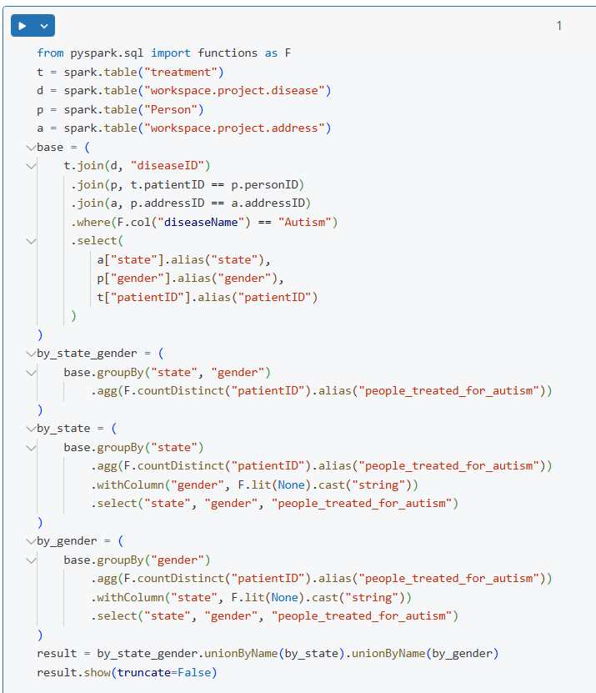
OUTPUT:
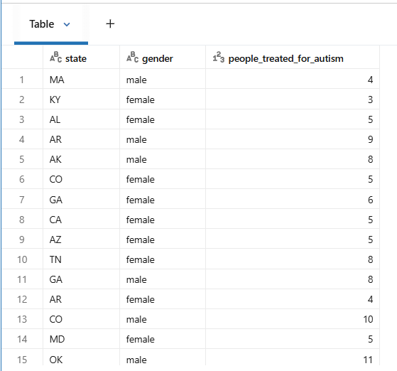

- Plan performance by year (2020, 2021, 2022) + total

CODE:
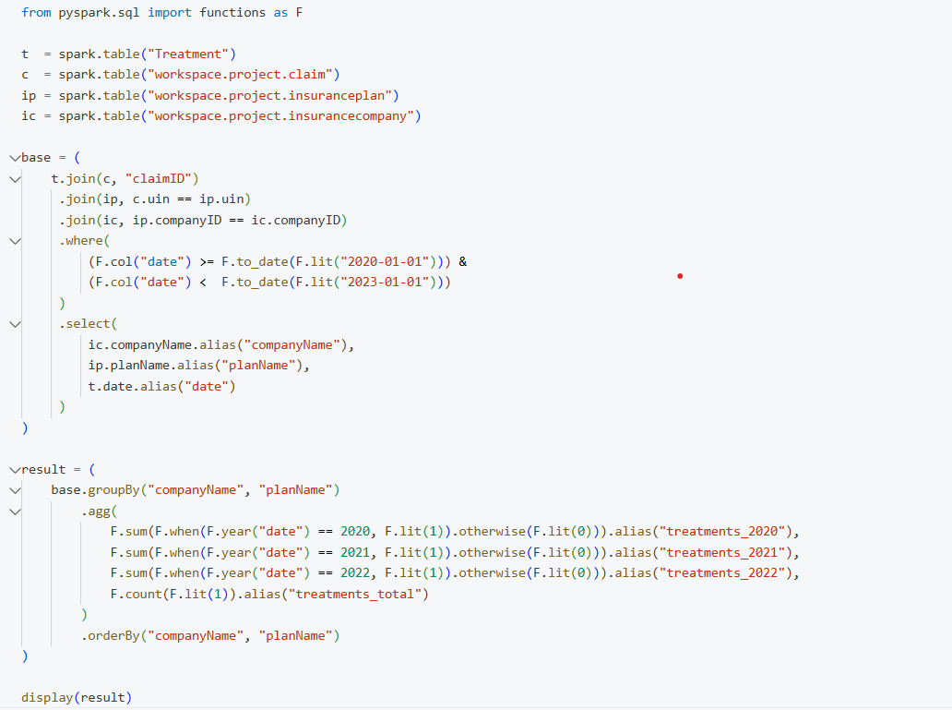
OUTPUT:
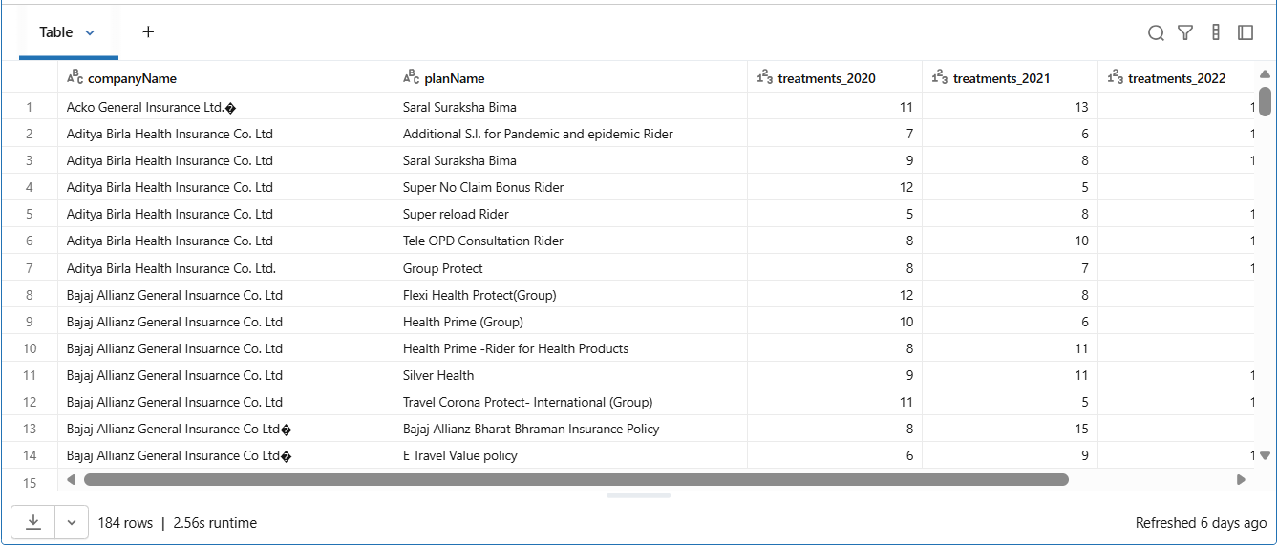

- State-wise disease counts & most/least in 2022

CODE:
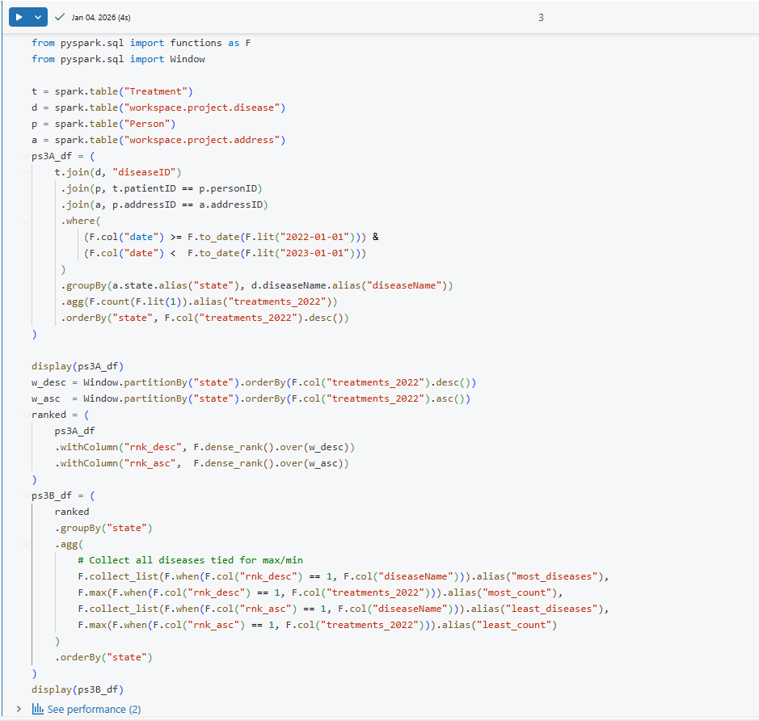
OUTPUT:
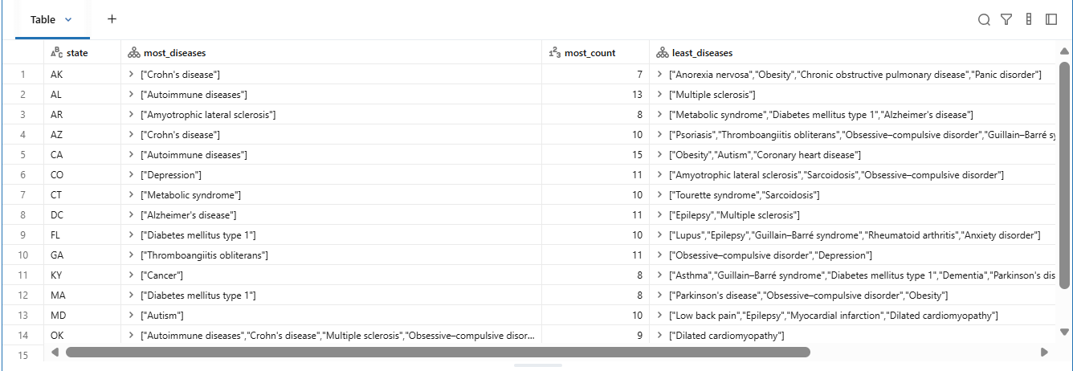
- Pharmacy × Disease prescriptions in 2022 + rollups

CODE:
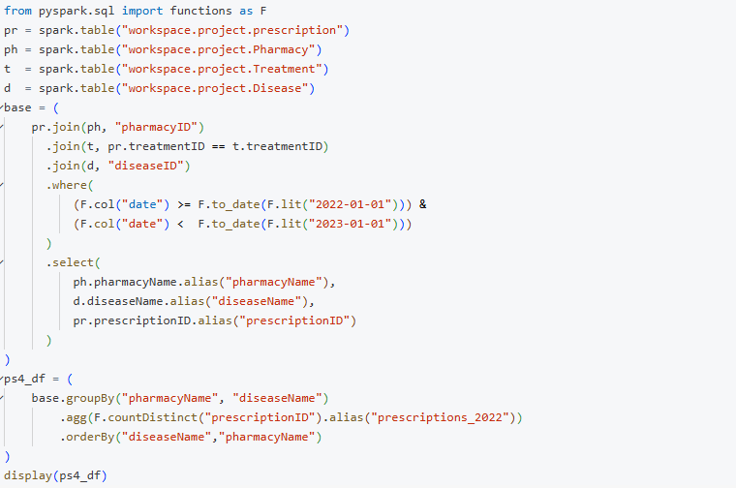
OUTPUT:
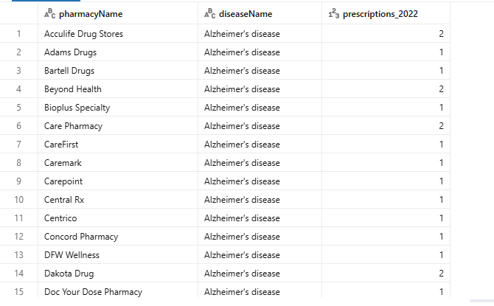

- Disease × Gender counts in 2022 + rollups

CODE:
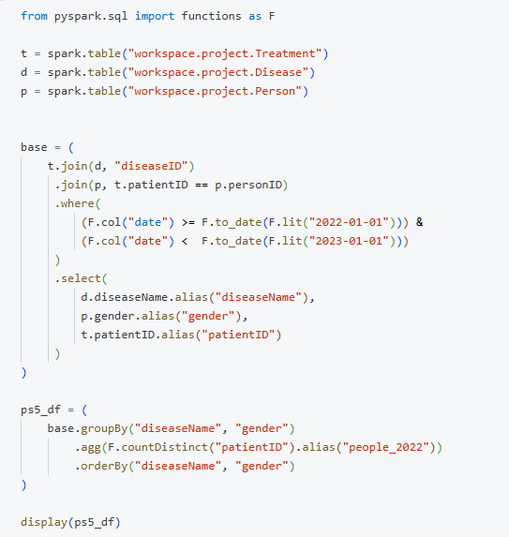
OUTPUT:
